Provisional Patent Application for a:

Programmable Pantograph-based Antenna Array

A product came on the market via IndieGogo that allowed receiving 4 software-defined-radio inputs at the same time. This creation is called the KerberosSDR. It provides the radio reception inputs. However there are issues once a skilled operator wishes to use it.

In order for the KerberosSDR, or other coherent (multiple synchronized inputs) radio hardware devices to properly work, **the antennas must be placed at a specific distance away**. The KerberosSDR offers no way to change the spacing of the antennas to match the frequency it has been tuned to. My device, a **programmable pantograph-based antenna array** allows for software to control the spacing of antennas to allow for ideal operation. The spacing is inversely derived from the frequency. The larger the spacing, the lower the feequency. I will go into the basics of this theory below.

Radio signals act as a wave. Radio operators measure this either in Hertz (cycles per second) or in the dimensions of the wave (meter). These always follow the the following formulas:

wavelength (λ) = speed of light (C) / frequency (Hz or f)

We can see as the frequency changes, the width of the wave (literally wavelength) changes. The KerberosSDR allows for frequencies from roughly 25MHz to 1700MHz.

In order to properly tune the antennas, the spacing between 4 antennas must be 1/3 the wavelength, so that from antenna 1 to antenna 4 is the wavelength of the frequency. See diagram 1.

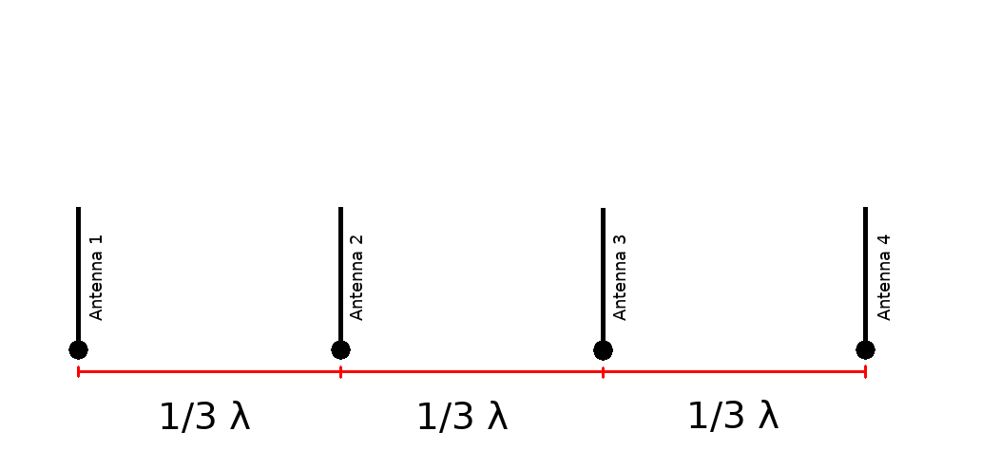Diagram 1

I accomplish software-controlled spacing of arbitrary number of elements in a 2 dimensional grid by way of a pantograph mechanism. Pantographs maintain even spacing between each cross vertices. By tuning the angle of incidence, one can accurately and repeatably tune to the wavelengths requested by a software defined radio operator.

The mechanical linkages can be seen with Diagram 2.

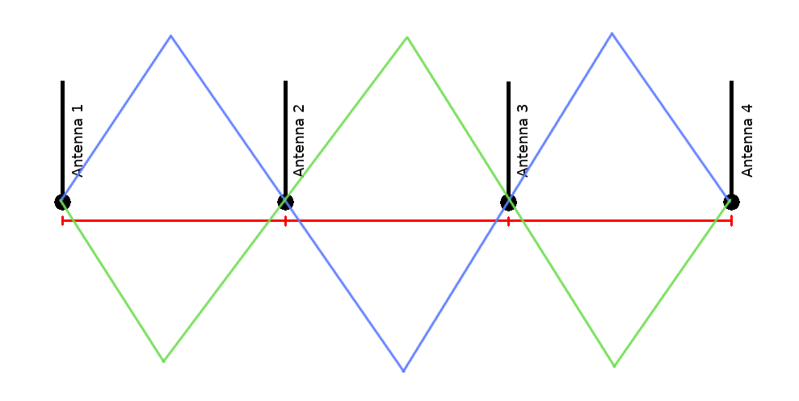diagram 2

The mechanism uses a threaded rod linked to a stepper motor. The mechanics are controlled with a commodity microcontroller. The nature of the pantograph mechanism enforces a constraint between the angles through the structure. By directly connecting from Antenna 1 to Antenna 4, we can control the full wavelength of the tuned array. With diagram 2’s positioning, we allow for a total of 4 antennas. Shortening or extending this is trivial by adding or subtracting more of the blue and green (pantograph) elements to suit the purpose of required number of antennas.

The length of the arms also is of some concern, with regards to the minimum and maximum frequencies available. The total length of one color section is the absolute maximum wavelength. This represents full extension. Instead, it is a good idea to consider a maximum of an angle to 5 degrees of horizontal. This would lead to max_length*sin(85 deg) as a maximum extension. Going further to max_length potentially causes the arms to flip and jam up and require a manual fix.

The minimum wavelength is the minimum distance of the antenna mount. The pantograph suffers no ill function from approaching minimum distances other than collision of antenna elements. It would be advised to design a half and a full arm as seen from diagram 2 with an idea of the maximum wavelength in mind. Do note, that the the arms will extend out perpendicularly approaching the footprint of the half-arm, and require that much clearance.

A spreadsheet will be attached to show a sample of frequencies, their wavelengths, and the calculated short and long arm calculations for that idea frequency. This will be **diagram 3**.

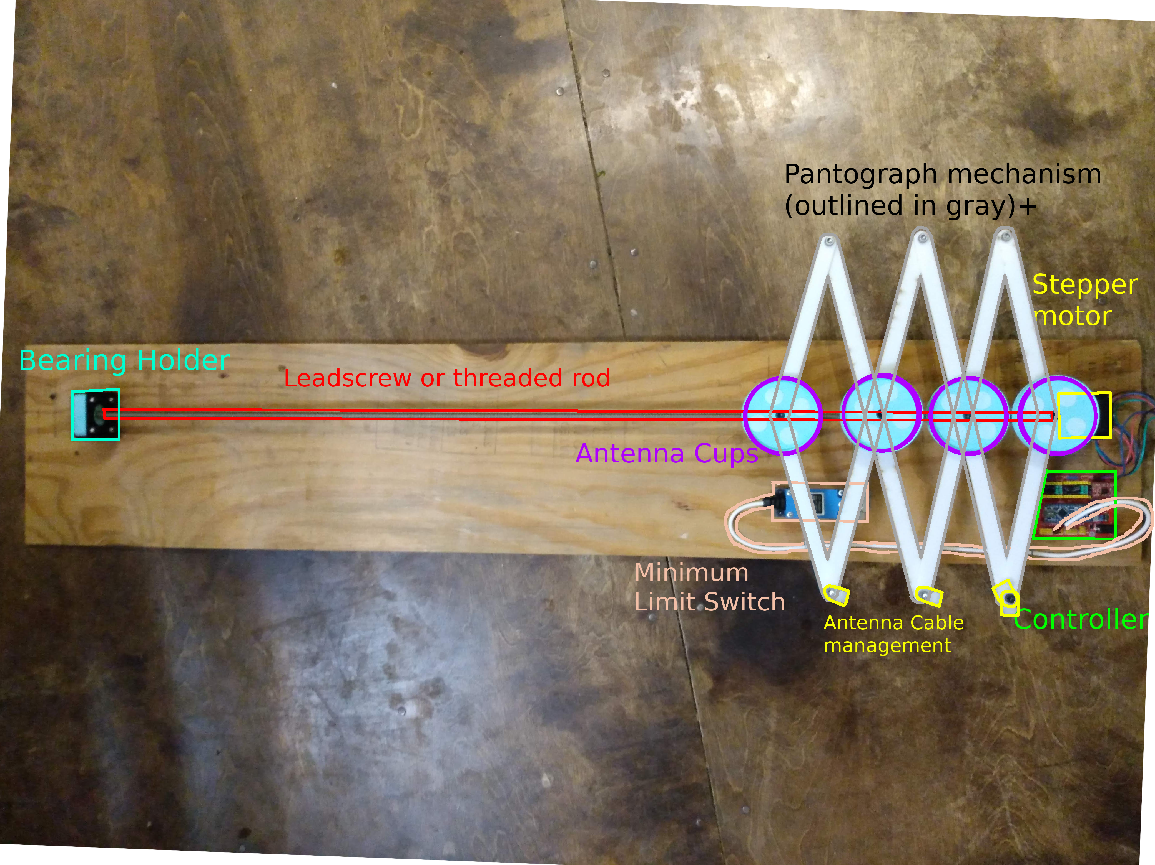Diagram 4

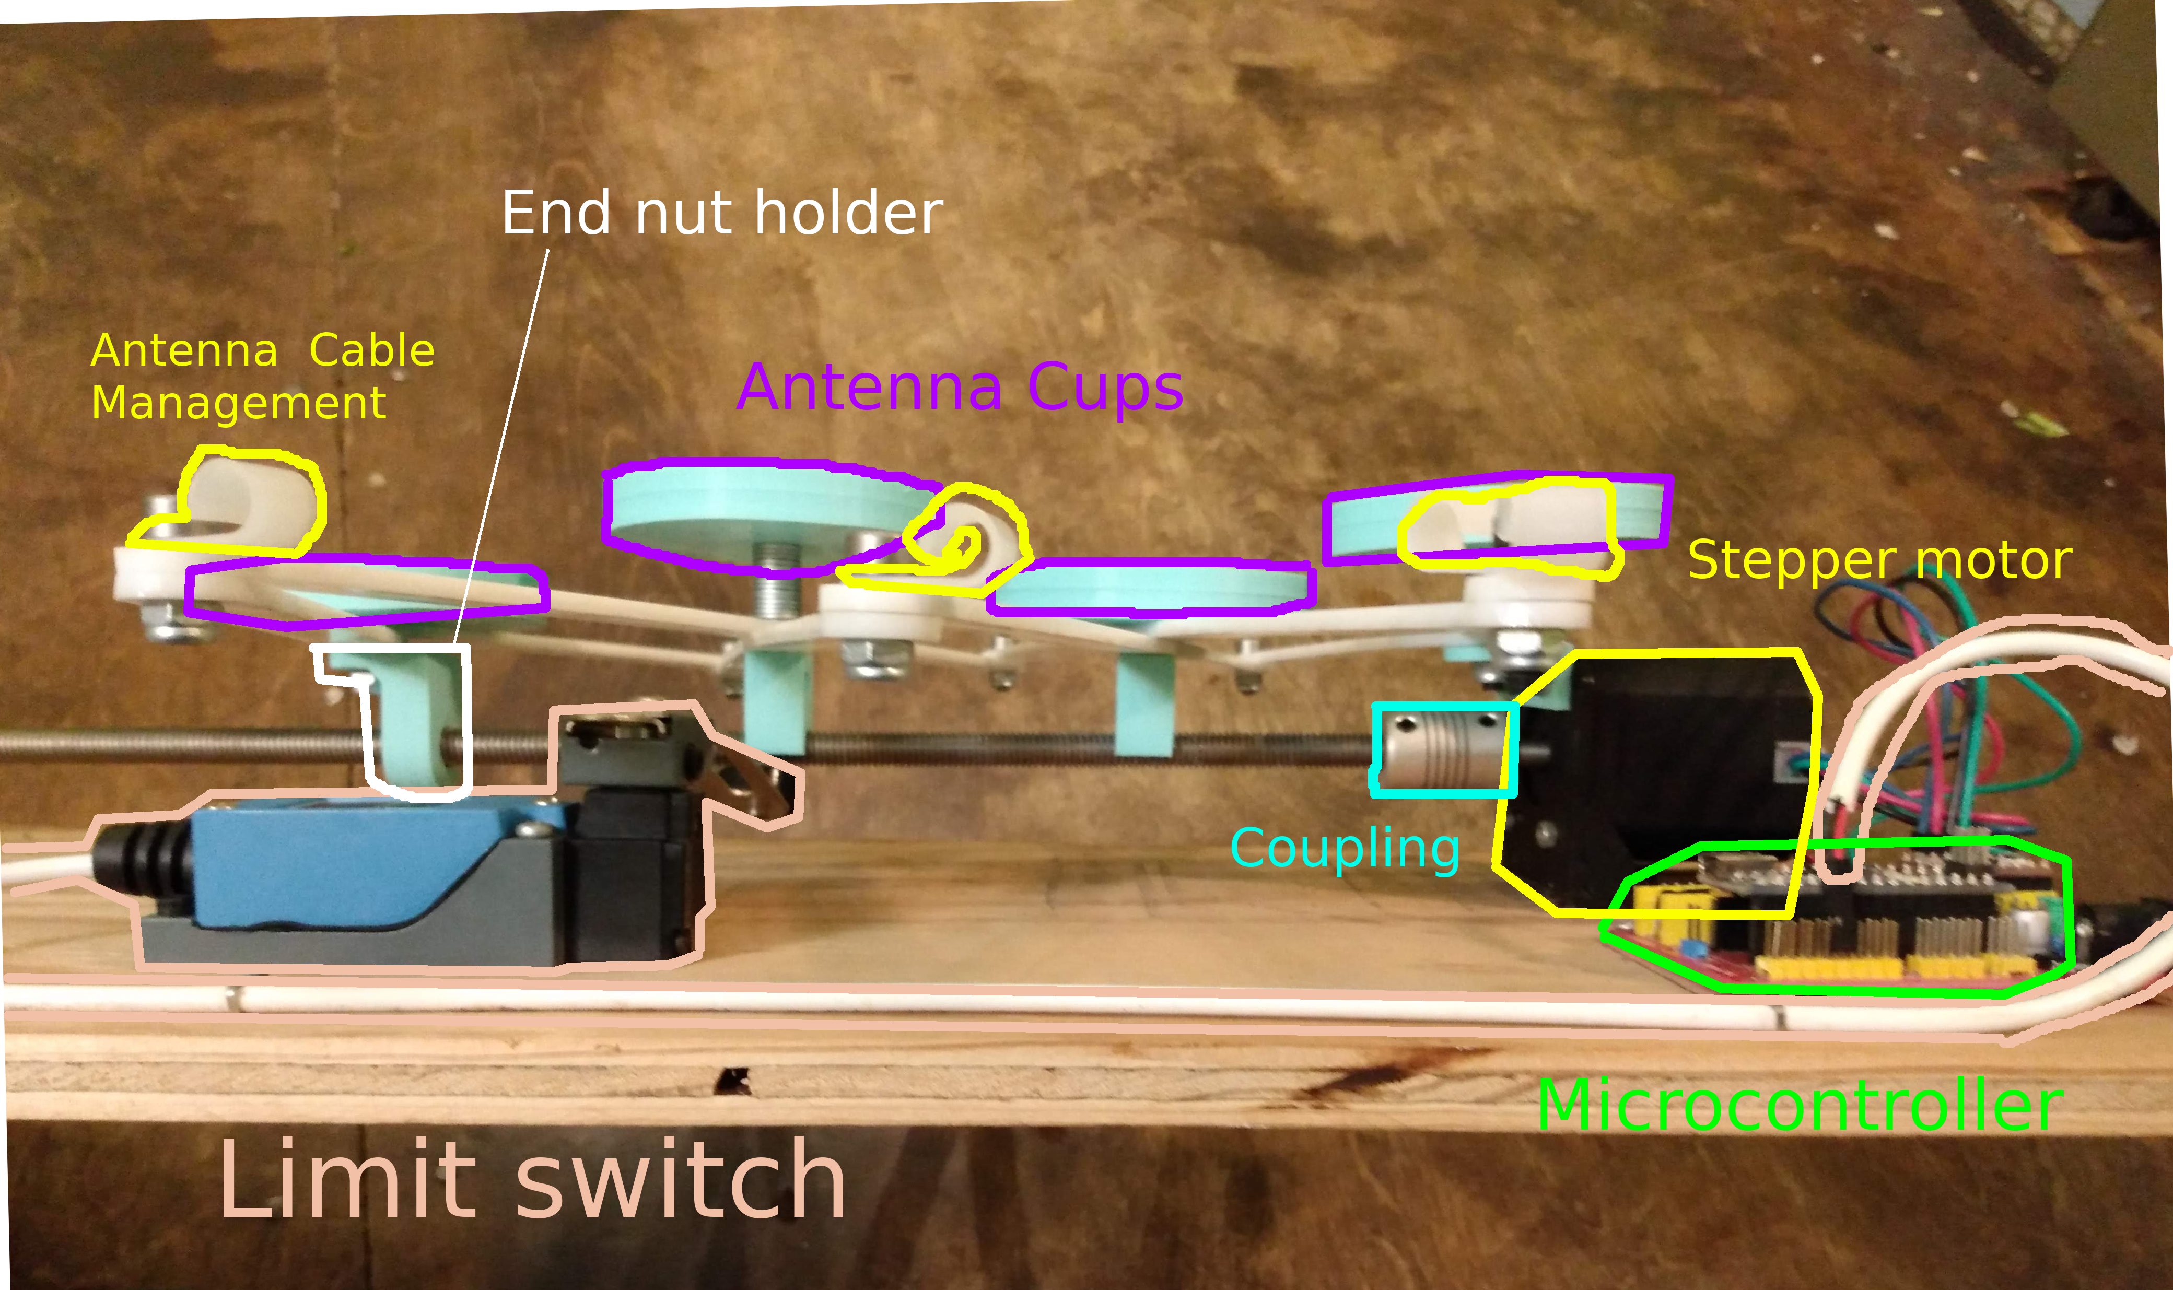Diagram 5

**Components:**

1. Controller: takes in power and provides USB controls (green)
2. Stepper motor: is controlled by controller and imparts rotational motion down the rod (bright yellow)
3. Shaft coupling: connects the stepper motor shaft to the rod. (teal)
4. Rod: imparts the rotational motion for control of the sizing of the array (red)
5. Minimum Limit switch: serves as minimum spacing and a calibration measurement (peach)
6. Bearing Holder: contains a rotational bearing to constrain the rod in the same line to prevent wobbles (teal blue)
7. Antenna cups: 3d printed antenna holders that mount directly to the cross-linked sections of the pantograph arms. (purple)
8. Pantograph mechanism: long and short sections of arms that guarantee and control equidistant spacing between antennas (gray outline, black text)
9. Antenna management: movable cable clips to keep the antenna cables from sprawling (yellow)
10. End nut holder: contains and constrains a nut for the respective rod. The nut is fixed inside the 3d printed part. Rotating the rod imparts linear motion closer and further away from the stepper motor.

**3D printed parts inventory, explanation:**

1. Antenna cup (diagram 6)

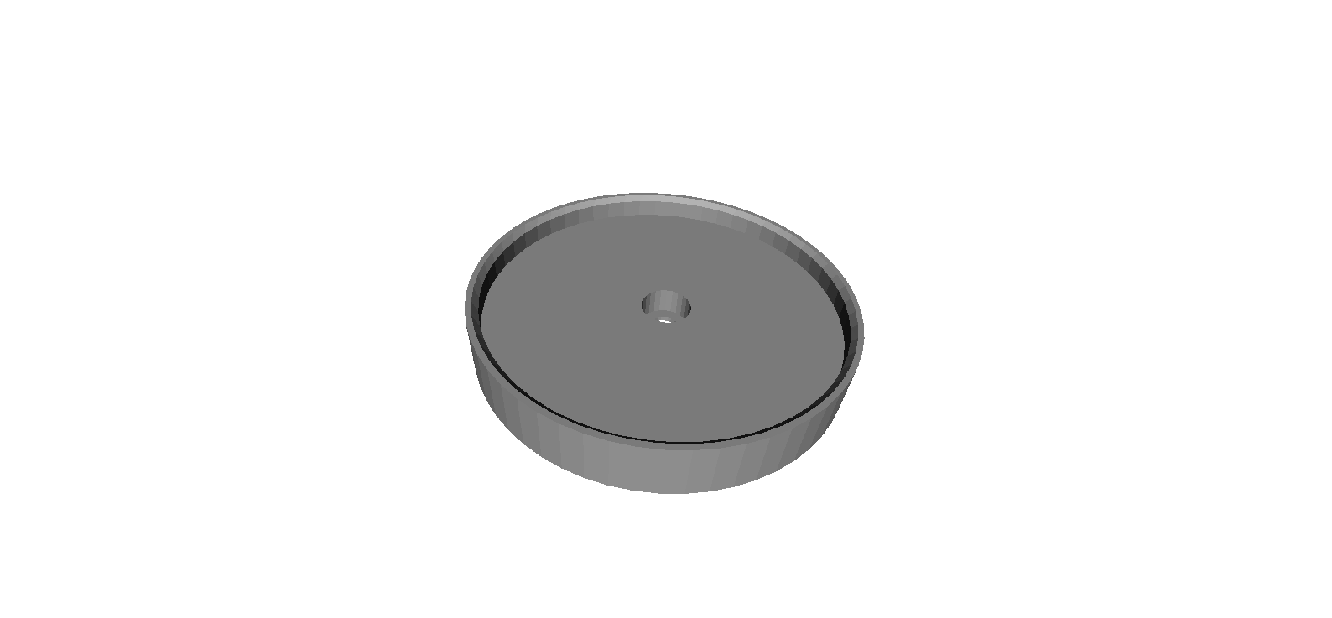

Used to hold the antenna base. The original model used was a NooELEC RatlSnake, but could be 3d printed to any base acquired or built.

2. Bearing constrainer (diagram 7)

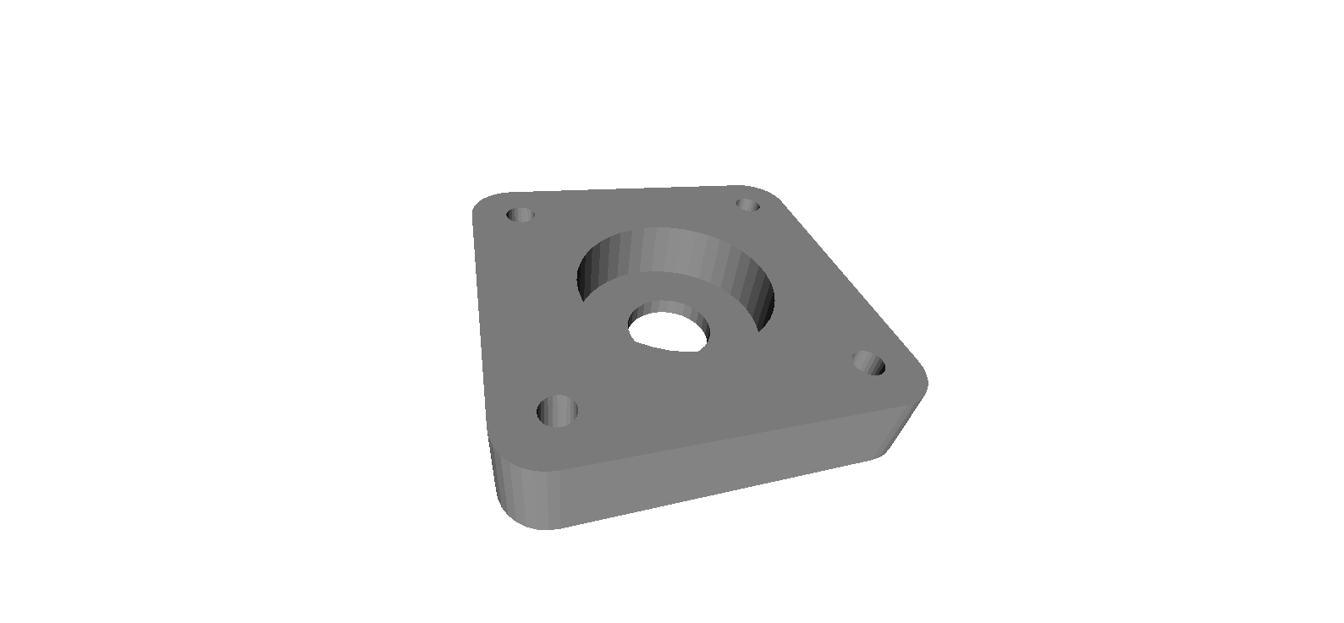

This is used in conjunction with a NEMA 17 motor bracket, the Bearing Constrainer cap, and a 608 bearing

3. Bearing Constrainer cap (diagram 8)

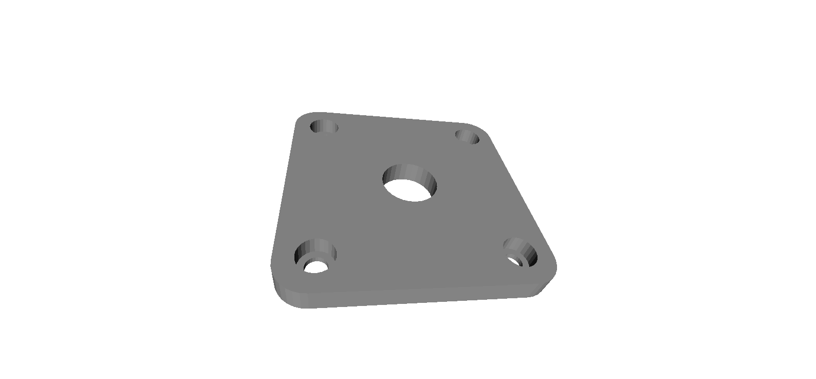

This cap’s purpose is to lock in the 608 bearing. The NEMA17 brackets are wider than the bearing and would fall out or onto the shaft. This prevents the bearing from moving. The center hole allows free clearance from the shaft

4. End nut holder (diagram 9)

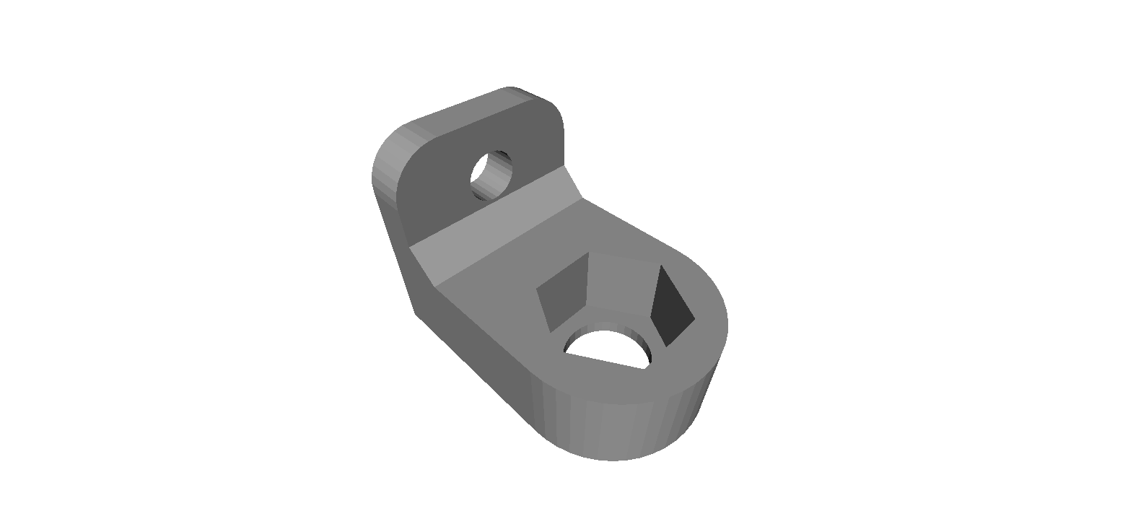

This part holds a nut (5/16” or 8mm) for the respective rod. The other hole is where the antenna cup and respective screw is placed. This is only 1 of 2 total places where the pantograph mechanism is fixed. Turning the stepper shaft causes this part to move closer or further away.

5. Stepper Bracket (diagram 10)

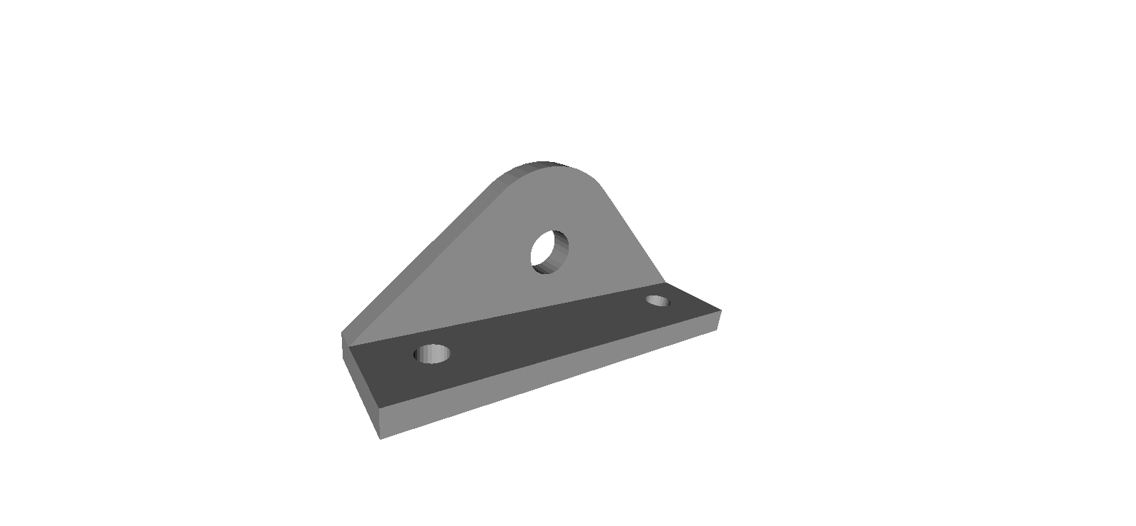

This part is affixed to the stepper motor and through the NEMA17 angle bracket through the 2 holes on the same surface. The hole on the rounded side is the underside of the first antenna cup and the location of the first antenna.

By combination of Stepper Bracket and End Nut holder, exact sizing is attained from Antenna 1(stepper bracket) to Antenna 4 (end nut holder). The pantograph mechanism enforces that Antennas 2 and 3 are equidistant from each other.

6. Standoff (diagram 11)

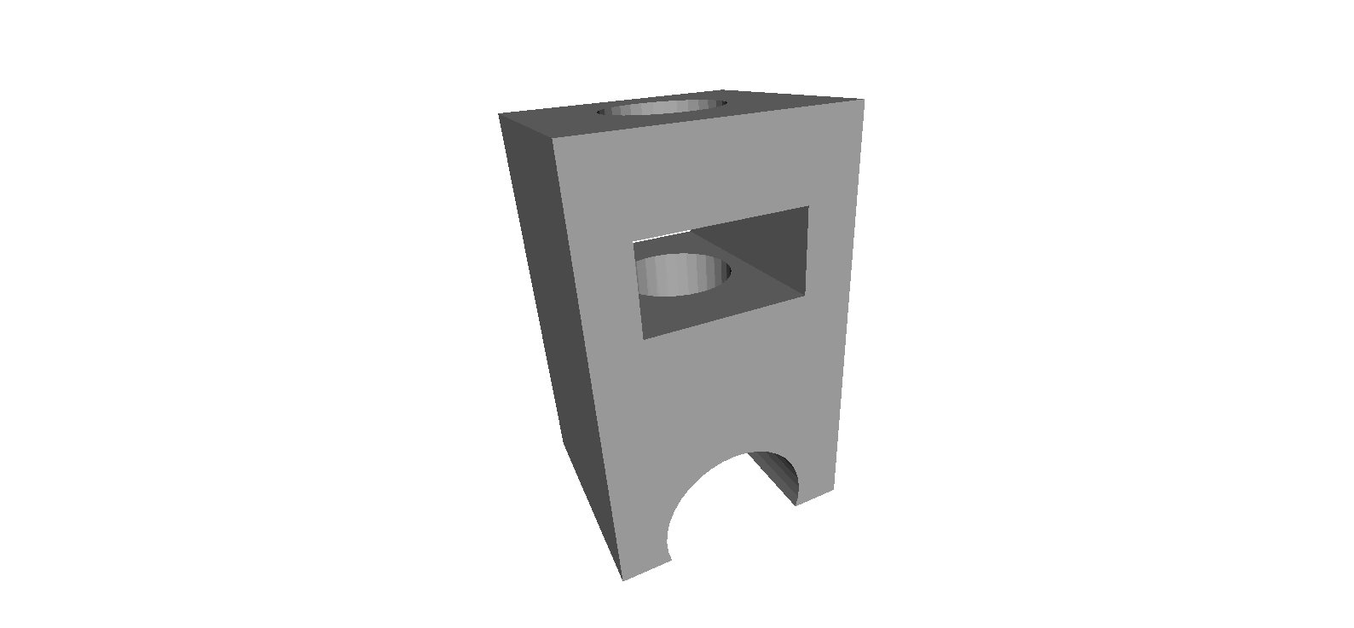

This part prevents the pantograph mechanism from drooping over the length when extended. This part is found on the underside of the Antenna 2 and Antenna 3, between the pantograph crossing and the rod.

**Lasercut parts:**

1. Pantograph arms (diagram 12)

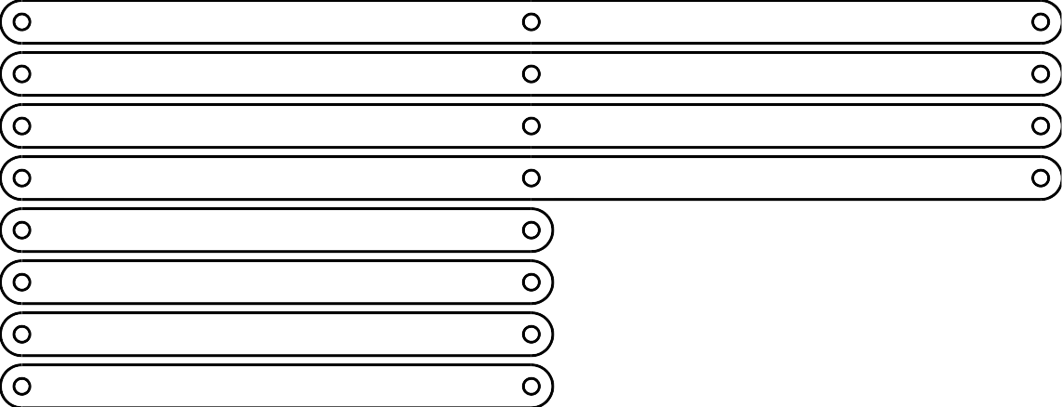

For a 4 antenna Pantograph network, 4 ‘short’ and 4 ‘long’ sections are needed. The long sections are 2x the size of the short, from mount-hole to mount-hole (not from edge to edge).

This model’s distance uses 166.14mm between mounting holes. This imparts a 400MHz-1800MHz frequency band. 400MHz is constrained by the max length of the array, or .75m long. The minimum is constrained only by the geometry of the antenna cups and bases.

One could make different half and full size pantograph sections to increase or decrease its minimum and maximum size. It would also be trivial to add more antenna sections by adding more long sections and keeping the 4 short sections. By removing the long sections, we could make a 2 antenna array. By following the formula, we can calculate the number of sections for the requested amount of antennas:

4 short sections + (2 long sections for each antenna past 2)

**Firmware:**

The code on the microcontroller maintains 2 primary functions.

First, is its requirement to home and get a starting location and beginning frequency to start positioning.

Secondly, the microcontroller then accepts frequency requests within its minimum-maximum band, and then adjusts the stepper motor to position the final element to the correct spacing as seen from Diagram 1 and Diagram 2.

Because this device can handle a variety of threaded rods, including metric, imperial, trapezoidal, ACME, and others, we handle translation of the thread pitch in firmware to accommodate all major thread pitches.